Q1.

Answer E, as the actual answer would be [2 2 -6] + [1 0 2 -4]

Q2.

Answer: B, I ran the following script:

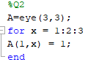

Q3.

Answer: C, I ran the following script and the output was 1 3 which matches C

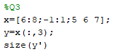

Q4.

Q5.

Answer: C, I ran the following script and the output was 1.9005

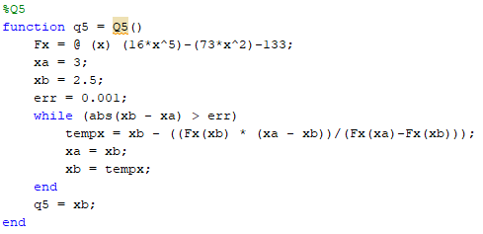

Q6.

Q7.